Task 1
Students are required to take an existing static website project containing HTML, CSS, and related assets and deploy it online using GitHub and its hosting service GitHubPages. After successful deployment, perform a maintenance activity by modifying some part of the website (such as updating text, changing images, or adding a small section) and upload the updated files to the repository so that the deployed website reflects the changes.
Students must submit the following:
1. GitHub Repository Link
https://github.com/Raazia-Imran/eduFord.github.io
- Clone the repository: git clone https://github.com/yourusername/eduford.git
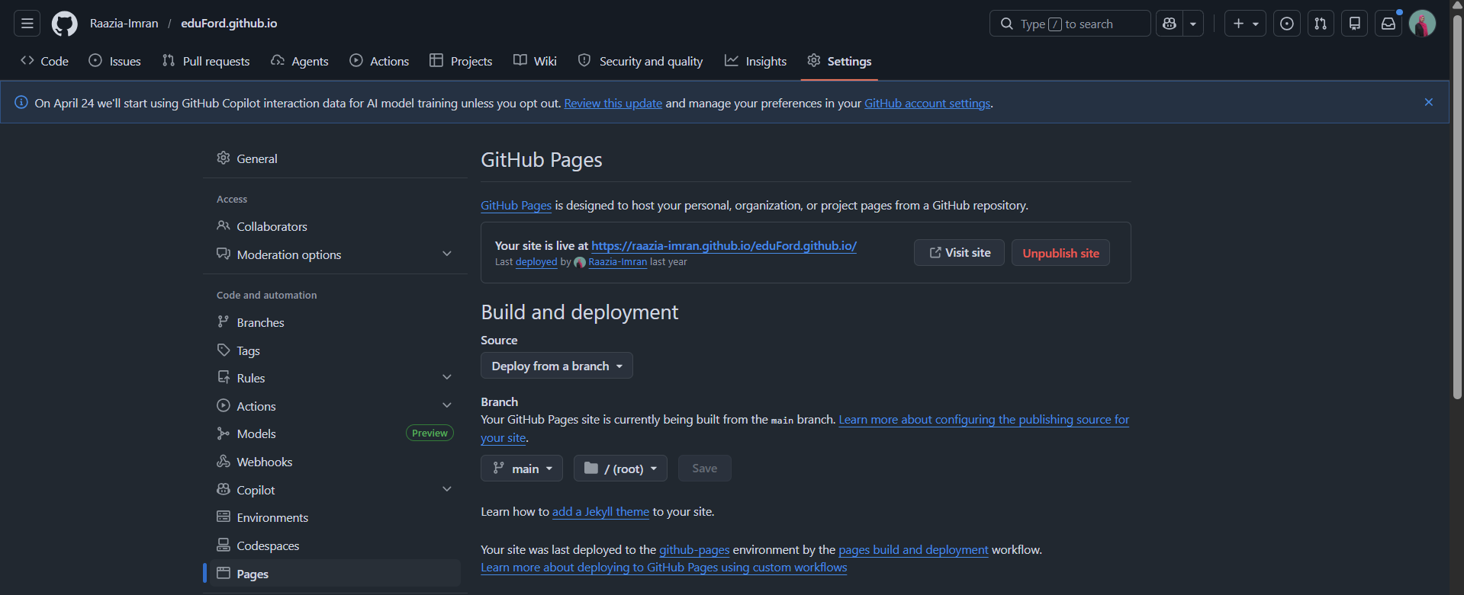

2. Live Website URL
Your site is live at https://raazia-imran.github.io/eduFord.github.io/

3. Screenshot of the deployed website




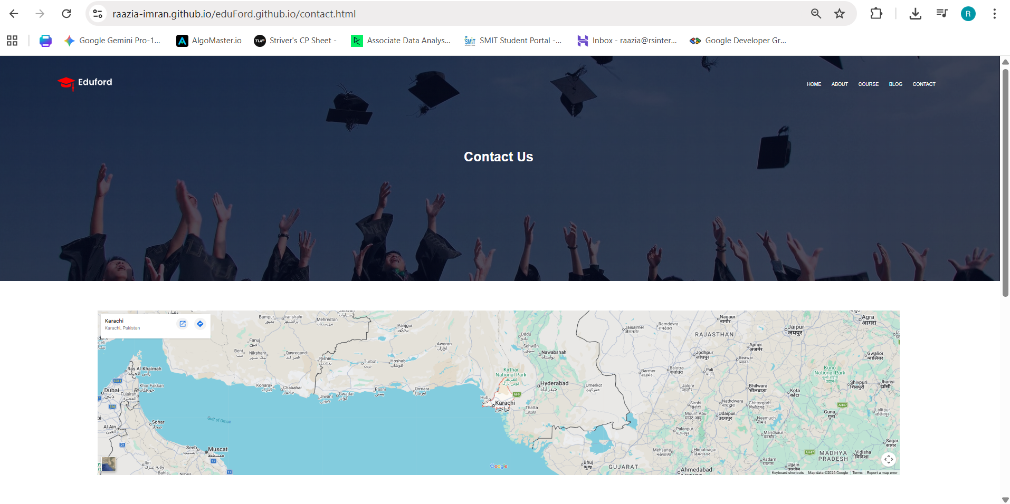
4. Screenshot after performing maintenance update
